
RAMAIAH
Institute of Technology
USN | 1 | M | S

(Autonomous Institute, Affiliated to VTU)
(Approved by AICTE, New Delhi & Govt. of Karnataka) Accredited by NBA & NAAC with ‘A’ Grade

SEMESTER END EXAMINATIONS – MAY/JUNE 2018

Course & Branch | : | B.E. : Common to all branches | Semester | : | II
Subject | : | Engineering Mathematics - II | Max. Marks | : | 100
Subject Code | : | MAT201 | Duration | : | 3 Hrs

Instructions to the Candidates:
- Answer one full question from each unit.

 |  | UNIT- I
1. | a) | Find: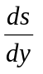 for the curve 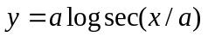 | CO1 | (02)
 | b) | Obtain the expression for radius of curvature in parametric form. | CO1 | (04)
 | c) | Find the extreme values of:  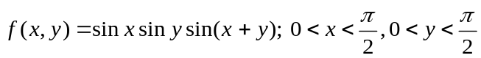. | CO1 | (07)
 | d) | Expand 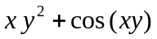 about 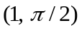upto second degree terms. | CO1 | (07)
2. | a) | State Taylor’s theorem for a function of single variable. | CO1 | (02)
 | b) | Find the values of and so that 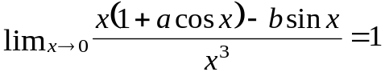 | CO1 | (04)
 | c) | Show that the volume of the greatest parallelopiped that can be inscribed in the ellipsoid 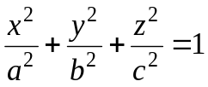 is 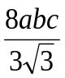. | CO1 | (07)
 | d) | Find the radius of curvature of the curve 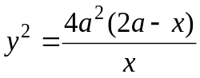 at the point where the curve meets the -axis. | CO1 | (07)
 |  | UNIT- II
3. | a) | Write Clairaut’s equation and also give its solution. | CO2 | (02)
 | b) | Test the exactness of the differential equation | CO2 | (04)
 | c) | Show that the family of Parabolas 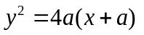is self orthogonal. | CO2 | (07)
 | d) | Solve 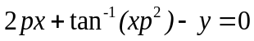 which is solvable for 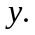 | CO2 | (07)
4. | a) | Write integrating factor for the homogenous equation | CO2 | (02)
 | b) | Solve 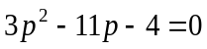 which is solvable for 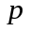. | CO2 | (04)
 | c) | Uranium disintegrates at a rate proportional to the amount present at any instant. If 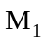 and 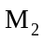grams of uranium are present at times and 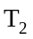respectively, then show that the half life of uranium is 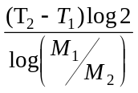. | CO2 | (07)
 | d) | Show that the orthogonal trajectories of the family of cardioids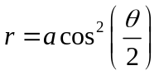 is the other family of cardioids 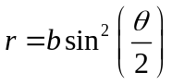. | CO2 | (07)
 |  | UNIT- III
5. | a) | Define the linear differential equation and give an example of a second order linear differential equation. | CO3 | (02)
 | b) | Solve : | CO3 | (04)
 | c) | Solve: 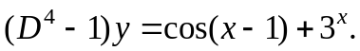 | CO3 | (07)
 | d) | Solve: | CO3 | (07)
6. | a) | Define an initial and boundary value problem. | CO3 | (02)
 | b) | If 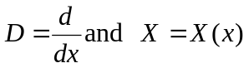, then prove that 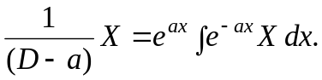 | CO3 | (04)
 | c) | Solve the differential equation 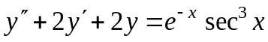 by the method of variation of parameters. | CO3 | (07)
 | d) | Solve 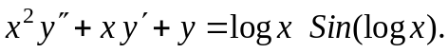 | CO3 | (07)
 |  | UNIT- IV
7. | a) | Define Dirac-Delta function and represent it graphically. | CO4 | (02)
 | b) | Obtain the Laplace transform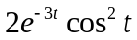. | CO4 | (04)
 | c) | Show that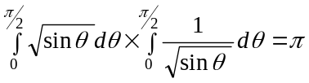 | CO4 | (07)
 | d) | (i) Evaluate the integral 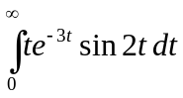 and ii) Find 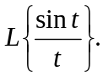 | CO4 | (07)
8. | a) | Write the formula for i) 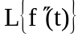 ii)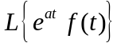. | CO4 | (02)
 | b) | Prove that 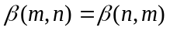 | CO4 | (04)
 | c) | Express 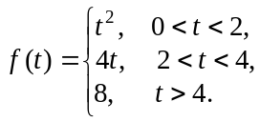in terms of the Heaviside function and hence find its Laplace transform. | CO4 | (07)
 | d) | If 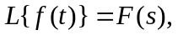 then prove that 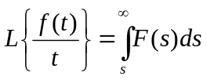 and hence evaluate 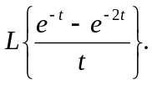 | CO4 | (07)
 |  | UNIT- V
9. | a) | Find 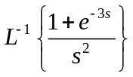. | CO5 | (02)
 | b) | Solve using Laplace transform | CO5 | (04)
 | c) | Verify convolution theorem for the pair of functions 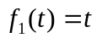and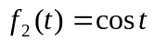 | CO5 | (07)
 | d) | Find the inverse Laplace transform of 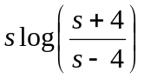 | CO5 | (07)
10. | a) | Define convolution of two functions. | CO5 | (02)
 | b) | Evaluate 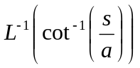 | CO5 | (04)
 | c) | Using Laplace transform method , solve the following simultaneous equations 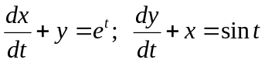, given 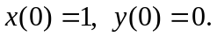 | CO5 | (07)
 | d) | Draw the graph of the periodic function 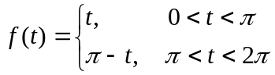 and find its Laplace transform. | CO5 | (07)

****************

